Anindya Dinar Maisarrah
M0401241032

Y | X
4.0056160 | 37.9575707
1.1964350 | 81.3541310
2.6473480 | 41.8300133
6.1661060 | 22.9589778
4.4988780 | 55.3530809
4.5813030 | 52.7891503
5.2472080 | 11.2500000
1.3965070 | 79.4178503
4.7445480 | 39.2147376
9.0060020 | 3.9013934
6.2166250 | 49.5263224
7.1433790 | 54.0085714
1.6755260 | 71.2996203
4.3061980 | 34.8648295
2.4460070 | 42.6689472
7.8142230 | 19.9651163
5.3599710 | 0.5923011
1.4651160 | 23.2558140
1.1618320 | 58.5933621
5.7636690 | 17.5647482
3.3333330 | 60.0000000
1.1073680 | 1.0526316
2.2448430 | 55.6985098
6.6492360 | 29.0089368
5.2233880 | 24.3750354
1.1370220 | 77.7584980
9.0917240 | 68.9555730
3.4785740 | 26.5546819
3.8544930 | 54.1069422
3.2382740 | 37.7938948

n = 30
Rata-rata Peubah
$$\overline{x} = \frac{\sum{x_{i}}}{n} = 41.1224$$
$\overline{y} = \frac{\sum{y_{i}}}{n} = 4.2067$

Komponen Keragaman
$$s_{xx} = \sum_{i = 1}^{n}{{\left(x_{i}-\overline{x}\right)}^{2} = 15614.6217}$$
$$s_{yy} = \sum_{i = 1}^{n}{{\left(y_{i}-\overline{y}\right)}^{2} = 159.7333}$$
$$s_{xy} = \sum_{i = 1}^{n}{\left(x_{i}-\overline{x}\right)\left(y_{i}-\overline{y}\right)=-590.6993}$$
Dugaan Parameter Regresi
Model regresi linear sederhana:
$$Y = β_{0} + β_{1}X + ε$$
Penduga parameter:
- Slope
$$\hat{β_{1}} = \frac{s_{xy}}{s_{xx}} = \frac{-590.6993}{15614.6217} = - 0.03783$$
- Intercept
$$\hat{β_{0} }= \overline{y} - \hat{β_{1}}\overline{x}$$
= 4.2067 – (- 0.03783) (41.1224)
= 5.76235
Persamaan Regresi
$$\hat{Y} = 5.76235 - 0.03783 X$$
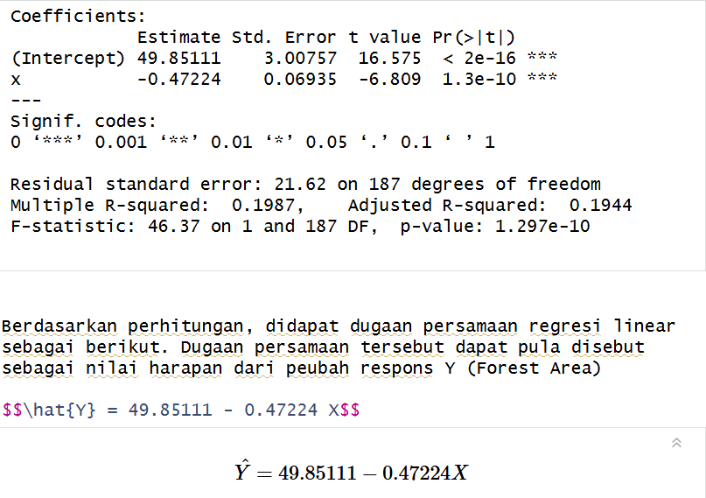
Jumlah Kuadrat
$$JKT = s_{yy} = 159.7333$$
$$JKR = \hat{β_{1}}s_{xy}$$
= (-0.03783) (-590.6993)
= 22.3461
JKG = JKT – JKR
= 159.7333 − 22.3461
= 137.3872
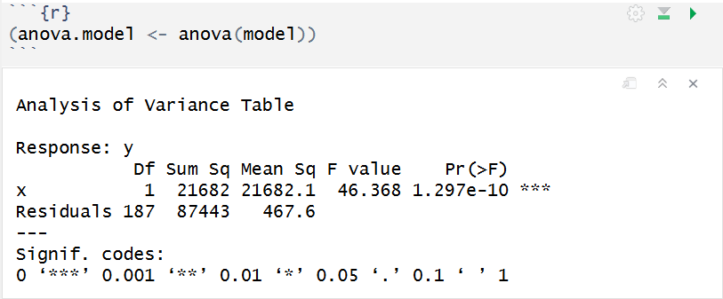
Ragam Galat
$$df = n - 2 = 28$$
$σ^{2} = \frac{JKG}{df}= \frac{137.3872}{28}= 4.9067$
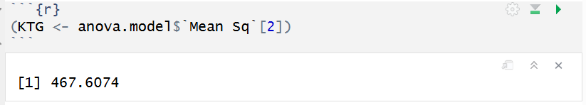
Tabel Sidik Ragam
Sumber | db | JK | KT | F
Regresi | 1 | 22.3461 | 22.3461 | 4.554
Galat | 28 | 137.3872 | 4.9067
Total | 29 | 159.7333

Statistik uji:
$$F = \frac{KTR}{KTG}= \frac{22.3461}{4.9067}= 4.554$$

Koefisien Determinasi
$$R^{2}= \frac{JKR}{JKT}= \frac{22.3461}{159.7333}= 0.1399 atau 13.99$$
Galat Baku:
$$S_{e}= \sqrt{σ^{2}}= 2.2151$$
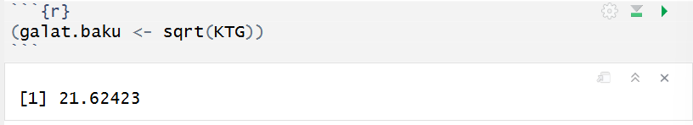
Keragaman Dugaan Parameter
$β_{0}=$5.76235
$$β_{1}= - 0.03783$$
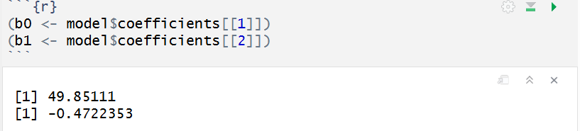
$$S_{\hat{β_{0}}}= \sqrt{KTG \left[\frac{1}{n} + \frac{{\overline{X}}^{2}}{\sum_{i = 1}^{n}{{(X_{i} - \overline{X})}^{2}}}\right]}; t_{h}= \frac{\hat{β_{0}} - β_{0}}{S_{\hat{β_{0}}}}$$
= $\sqrt{0.689}$
= 0.830
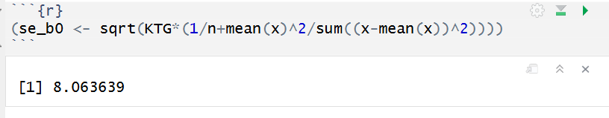
$$S_{\hat{β_{1}}}= \sqrt{ \left[ \frac{KTG}{\sum_{i = 1}^{n}{{(x_{i} - \overline{x})}^{2}}}\right]}; t_{h}= \frac{\hat{β_{1}} - β_{1}}{S_{\hat{β_{1}}}}$$
= $\sqrt{0.000314}$
= 0.0177
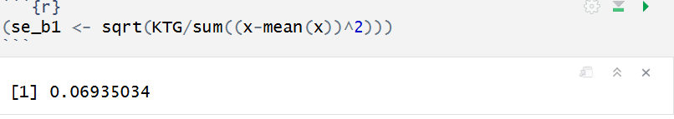
Selang Kepercayaan
$$t_{0.025,28}= 2.048$$
$$β_{0} : \hat{β_{0}} ± t_{α/2,n - 2}S_{\hat{β_{0}}}$$
5.7623 ± 2.048 (0.830)
5.7623 ± 1.700
Sehingga: CI ($β_{0}$) = (4.062, 7.462)
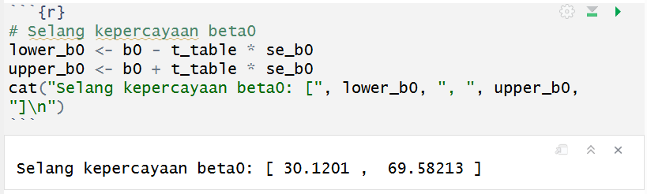
$$β_{1} : \hat{β_{1}} ± t_{α/2,n - 2}S_{\hat{β_{1}}}$$
−0.03783 ± 2.048 (0.0177)
−0.03783 ± 0.0363
Sehingga : CI ($β_{1}$) = (-0.0741, -0.0015)
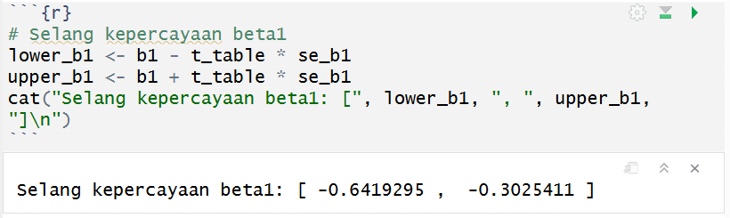
- Bagi nilai harapan amatan
$$E(\hat{Y} | X = x_{0}) ± t_{α/2,n - 2}S_{e}\sqrt{(\frac{1}{n}+ \frac{{(x_{i} - \overline{x} )}^{2}}{\sum_{i = 1}^{n}{{(x_{i} - \overline{x})}^{2}}})}$$
$$\overset{ˉ}{x}=41.1224$$
$$S_{xx}=∑(x_{i}-\overset{ˉ}{x})^{2}=15614.6217$$
$$S_{e}=\sqrt{MSE}=\sqrt{4.9067}=2.215$$
$$t_{0.025,28}=2.048$$
Misal $x_{0}=10$
- $\hat{y_{0}} = b_{0}+ b_{1}x_{0}$
$$\hat{y_{0}}=5.7623-0.03783\left(10\right) \\ \hat{y_{0}}=5.384$$

- $\frac{1}{n}= \frac{1}{30 } = 0.03333$
$$\left(x_{0}-\overset{ˉ}{x})^{2}=(10-41.1224)^{2}\right.$$ $=968.603$
$$\frac{968.603}{15614.6217}=0.06203$$
$$0.03333+0.06203=0.09536$$
$$\sqrt{0.09536}=0.3088$$
- standar error:
Se​ × 0.3088
$$2.215×0.3088=0.684$$
d. Batas selang:
2.048 × 0.684 = 1.401

CI = 4.249 $± 1.401$
= (3.983, 6.785)

Selang kepercayaan 95% untuk nilai harapan respon $Y$ketika $X=10$adalah

(3.983, 6.785)
Artinya rata-rata nilai $Y$pada populasi dengan $X=10$ diperkirakan berada pada selang tersebut dengan tingkat kepercayaan 95%.
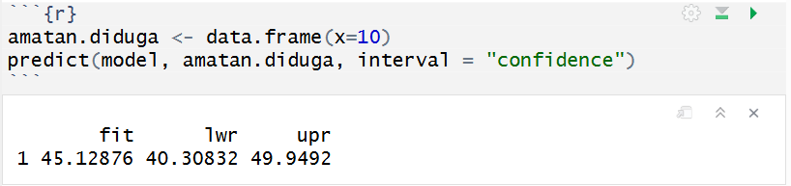
- Bagi individu amatan
$$\hat{y}(x_{i}) ± t_{α/2,n - 2}S_{e}\sqrt{1 + (\frac{1}{n} + \frac{{(x_{i} - \overline{x} )}^{2}}{\sum_{i = 1}^{n}{{(x_{i} - \overline{x})}^{2}}}}$$
Misal: $x_{i} = 10$
$\hat{y}$​(10) = 5.7623 − 0.03783 (10)
$$\hat{y}(10)=5.384$$
- $\frac{1}{n}= \frac{1}{30 } = 0.03333$
$$\left(x_{0}-\overset{ˉ}{x})^{2}=(10-41.1224)^{2}\right.$$ $=968.603$
$$\frac{968.603}{15614.6217}=0.06203$$
$$0.03333+0.06203=0.09536$$
$$1+0.09536=1.09536 \\ \sqrt{1.09536}=1.0466$$
- Standar error
Se ​× 1.0466
$$2.215×1.0466=2.318$$
- Batas selang
2.048 × 2.318 = 4.747

CI = 5.384 ± 4.747
= (0.637, 10.131)

Selang prediksi 95% untuk nilai individu $Y$ketika $X=10$adalah
$$\left(0.637, 10.131\right)$$
Artinya nilai individu respon $Y$ketika $X=10$ diperkirakan berada pada selang tersebut dengan tingkat kepercayaan 95%.
